Magus Manual

Version 0.3

Introduction 3
Magus – the application 4
File menu 4
Tools menu 5
Magus project 6
General project settings 8
General settings 8
Actions 9
Window settings 10
Window - mainwindow 10
Window - docking window 10
Menu 11
Default Actions 12
Toolbar 12
Tab 13
Use Ogre3d 14
Magus – the library (Qt) 15
Generic asset library 16
Example: Create an Asset 17
Example: Create a container and add properties to the container 17
Example: Value of a property changes 17
QtCurveDialog 18
Ogre asset library 19
Ogre asset widget overview 20
Node editor library 24
Tools library 25
Gradient widget 25
Texture widget 26
Extended Texture widget 27
Layer widget 28
Sceneview widget 28
Layered Sceneview widget 29
Sample applications 30
Node Editor 30
Tools 30
Simple Material Editor 30
EditorDockWidget – editor widget 31
EditorDockWidget – node creation 32
EditorDockWidget – material generation 32
AssetDockWidget – asset creation 32
Connection policies 32
Magus – points of attention 33

Introduction
Magus is a (Windows) tool that generates C++ code for GUI applications and offers a set of standard widgets to quickly create an application. Magus contains:
- The Magus wizzard – this application generates a c++ project, based on a template. The template can be modified in the application. Currently only Qt projects are supported.
- An iconset – The application comes with a set of icons (512x512) specific for 3D type of applications. It is possible to use your own icons.
- The Magus library – In addition, Magus comes with a set of extra widgets to support fast development. These widgets produce no additional c++ code. If you want to use them, you have to write your own code (which is relatively easy). Examples are included in the manual.

The figure below illustrates in a nutshell what Magus does:

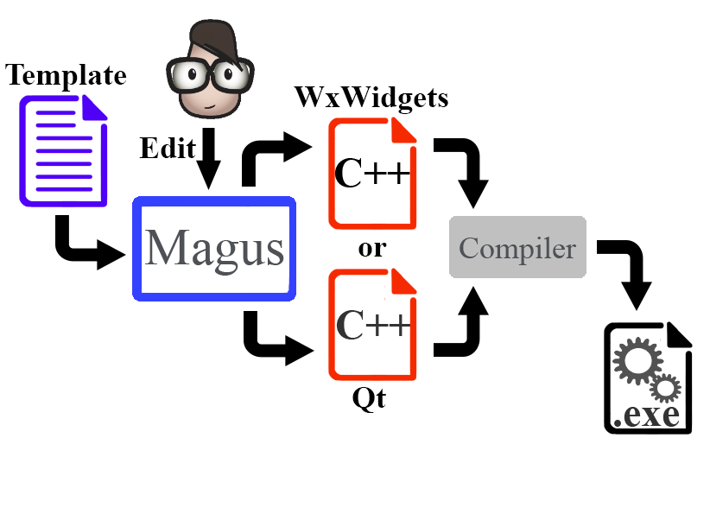

Magus – the application
After starting the Magus wizzard application, an empty screen with a menu is displayed.

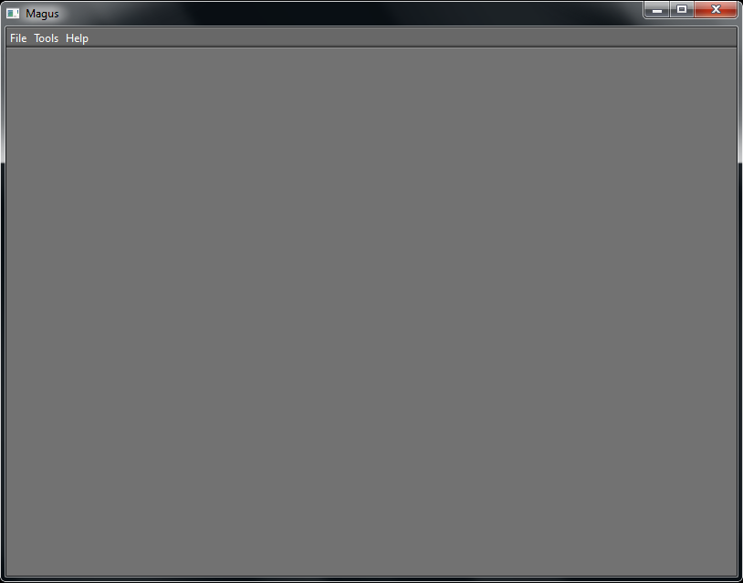

File menu

New project | Create a new project. This opens a dialog with a number of templates from were the user can make a choice. The template is a good start and already has some settings for docking windows, menu items and toolbars.
Open… | Open a project that was previously saved.
Save project | Save the project. By default, this is the name of the template, but another name can be given to the project.
Build | Generate all project files (C++ code, images, etc.)
Exit | Quit the application.

Tools menu

Config | Opens a configuration dialog. The configuration dialog updates the settings in the file global.cfg.

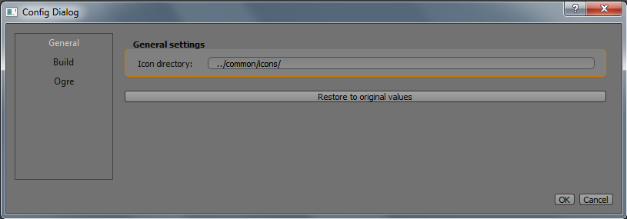

The config dialog has a few settings:

General  > icon directory | The directory that refers to the icon images used by the Magus application.
Build  > Output directory | The directory where Magus writes the ‘builds’.
Ogre  > environment variable | If selected, the environment variable is used to point to the Ogre root directory.
Ogre  > root directory | If selected, the given directory is used as Ogre root directory.

Magus project
Select ‘New project’ and select template layout_2.ide, for example:

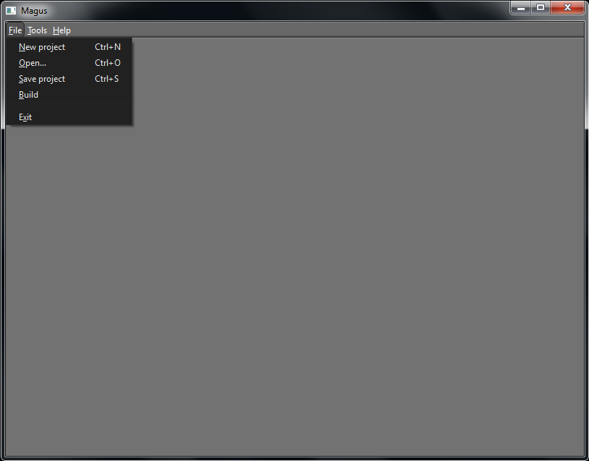

This results in 4 tabs, which represent generic settings, a main window (with a menu) and 2 dockable windows.

Select ‘Build’ from the menu. This generates all C++ code, including all addional files. In case of Qt, a Layout2.po file is generated, so the project can easily be used in combination with Qt Creator.
By default, Magus writes the project to c:/temp/magus_out/Layout2
For Qt, just open Layout2.pro in Qt Creator and run the application.

Note
The target (build) directory is defined in a configuration file. This file can be found in /magus/bin/ and is called global.cfg.
These settings can be changed by means of a configuration dialog (see next section).

Note, for Ogre3d usage:
If Ogre3d is used, Magus generates C++ code that refer to Ogre3d header files. It also generates a .po file with a reference to the Ogre3d source directory. This source directory is defined in the global.cfg. The tag ogre_root_env refers to an environment variable. By default this environment variable is called OGRE_ROOT, but you also defined your own environment variable.
If no ogre_root_env tag is specified, it is also possible to specify the directory by means of ogre_root.

The Ogre settings can also be changed by means of the configuration dialog.

General project settings

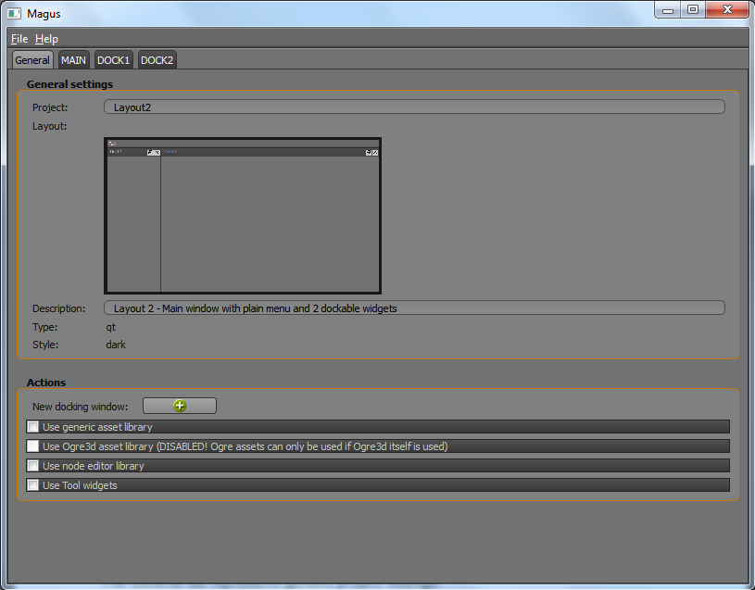

The General tab represents generic project settings:

General settings

Project | Name of the project. When the project is build, this becomes the name of the root directory.
Layout | Visual representation of the layout (this is a static image).
Description | Description of the project.
Type | Determines the type of project is generated. Default is a Qt project. Wxwidgets is not available yet.
Style | Style of the application. In case of Qt this is the ‘dark’ style by default. Other styles aren’t available (yet).

Actions

New docking window | Adds another docking window to the project. This new window is represented by another tab in the Magus application.
Use generic asset library | Not everything can be build automatically. Magus provides additional asset widgets that can be used in the application. When this checkbox is checked, the generic asset files are added to the generated project.  See next chapter for more details.
Use Ogre3d asset library | In addition, Magus also provides asset widgets specific for the Ogre rendering engine. The Ogre asset widgets depend on the generic asset widgets. When checked, all asset files are added to the generated project.  See next chapter for more details.
Use node editor library | Include the c++ files of the node editor widget
Use Tools widgets | Additional widgets for image/icon selection, gradient creation, …etc.

Window settings
Each application, generate by Magus, has one main window and zero or more docking windows. The mainwindow differs on certain features; deleting the mainwindow and adding tabs is not possible.

Window - mainwindow

Title | Title of the window. This name is also used to generate C++ code (in the filename and the classname); any special character that is not allowed in a C++ classname is stripped from the title.  If the checkbox ‘Display the title of the window’ is checked, the title is displayed in the titlebar.
Order | The order of a mainwindow is always 0. Order is used as a ‘window index’.

Window - docking window
The window properties of a docking window has some additional options.

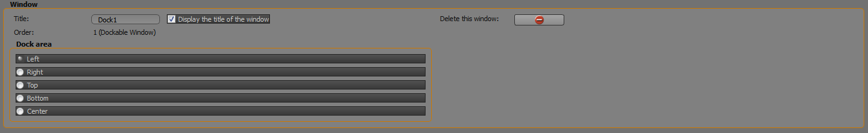

Title | See above
Order | See above; the order > 0
Dock area | Define the area in the mainwindow where this docking window initially is set.
Delete this window | The current tab is deleted, which implies that the docking window associated with this tab is not generated after a ‘build’.

Menu

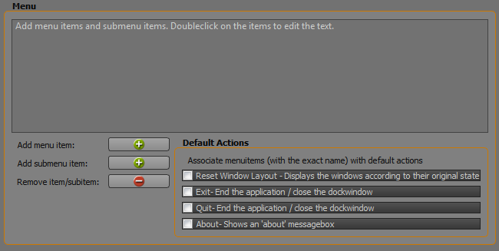

Each window (mainwindow and docking window) may have its own menu (horizontally positioned right under the titlebar.

Add menu item | Add a menu item to the menutree (i.e File, Edit, Window, Help). The menu items are distributed horizontally in the menu.
Add submenu item | Add a subitem to the menutree. A subitem is an item positioned under a menu item (vertically distributed).
Remove item/subitem | Remove the currently selected item or subitem.
Menutree | The menutree is a representation of the menu. Each menuitem and subitem can be edited by doubleclicking on it.

Default Actions
A default action is a preconfigured action, which can be associated with a submenu item. The association is based on the exact name of the subitem and the default action. E.g. if the application has an Exit-action, the subitem name must be named exactly ‘Exit’.

Reset Window Layout | If this is checked and one of the subitems in the menu is named ‘Reset Window Layout’, all docking windows are positioned according their original position.
Exit | If checked and one of the subitems in the menu is named ‘Exit’, the application quits when this subitem is selected.
Quit | Same as ‘Exit’, but with the ‘Quit’ keyword.
About | If checked and one of the subitems in the menu is named ‘About’, an About messagebox is displayed when the subitem is selected. Note, that this is a basic About messagebox. You have to change it to your own needs.

Toolbar
Magus has a Toolbargroup with which it is possible to create a horizontal and /or vertical toolbar. This is done by dragging and dropping the icons from the iconoverview to the horizontal and/or vertical area. In the image below, the ‘Primitives’ icons are selected by means of the combobox. Two of these icons are dragged/droppen on the vertical toolbar. The horizontal toolbar contains ‘File’ icons.

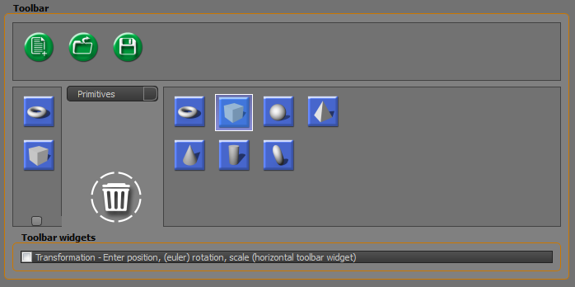
Icon area
Horizontal toolbar area
Vertical toolbar area

Combobox | Icons are grouped into categories. The categories are selected by means of this combobox. There is one special category named ‘Separator’. An icon of this type is translated into a real separator in the generated toolbar.  Note:  The grouping in categories is defined in a file called icons.cfg (in the bin directory)
Icon area | The icons from where you can select are displayed in this area.
Horizontal toolbar area | Icons can be dragged from the Icon area to the Horizontal toolbar area
Vertical toolbar area | Icons can be dragged from the Icon area to the Vertical toolbar area
Bin   | An icon in the Horizontal/Vertical toolbar area can be removed by dragging and dropping on the Bin.
Transformation | Additional (custom) widgets can be added to the toolbar. Currently, there is only one widget called ‘Transformation’. This widget can be used to change Position, (Euler) Rotation and Scale of an object. This usually is a selected object in a renderwindow.  Note:  This widget on its own has no meaning. It must be used in combination with your own code.

Tab
Tabs can be added to each docking window.

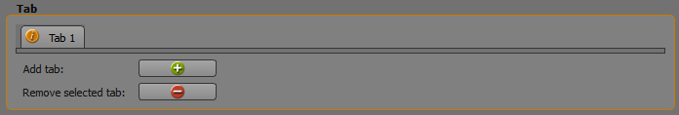

Add tab | Create a new tab. The tab has a default name (‘Doubleclick to edit’) and a default icon (an ‘i’ icon). Both the tab text and the icon can be changed by doubleclicking on the tab.  This displays a dialog in which both tabtitle and icon can be changed.
Remove selected tab | Remove the currently selected tab.

Use Ogre3d
Magus makes it possible to use Ogre3d in combination with the generated project. It adds an Ogre widget to a specific target (mainwindow, docking window or tab).

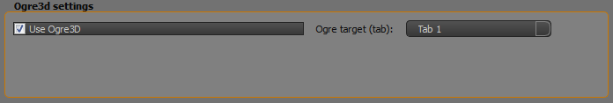

Use Ogre 3D | If checked, code is generated that adds an Ogre 3D renderwidget
Ogre target (tab) | By default the Ogre renderwidget is set in the window itself, but is tabs are defined, the renderwidget is set in one of the selected tab.

Magus – the library (Qt)
Magus only generates the code of a basic GUI framework; its purpose is not to create a fully working application. Creating a real application requires additional coding. Magus speeds up development with a set of additional widgets. These widgets are grouped into several libraries:
- Generic asset library – Widgets for assets and properties.
- Ogre3d asset library – Widgets for Ogre3d; these are to demonstrate how to use the generic asset library.
- Node editor – An easy to use node editor.
- Tool widgets – Additional widgets for various purposes.

The libraries can be added to a project by means of the Magus wizzard application. Create a new project and select one or more libraries in the General tab.

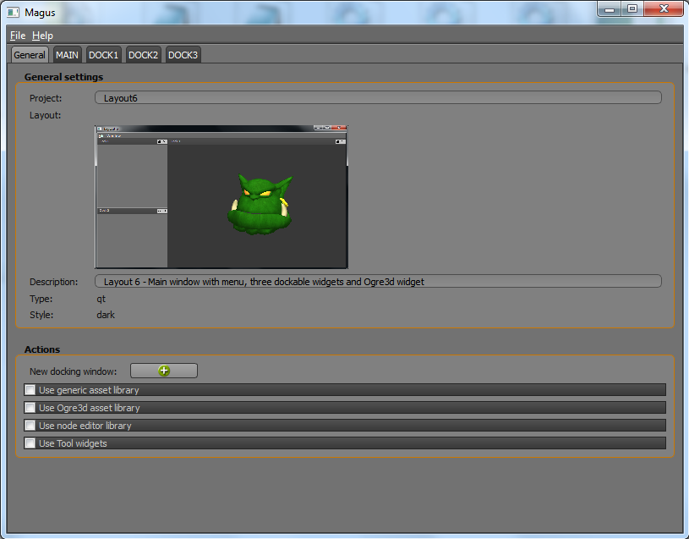

Currently only Qt libraries are present.

Generic asset library
The generic asset library is all about assets and properties. C++ files that are part of the Generic Asset library are:
asset*.h / asset*.cpp

- The main widget is QtAssetWidget (see asset_assetwidget.h). QtAssetWidget contains a header with title, an icon (optional) and 2 optional action icons. The action icons can be used to perform a certain action on the widget or the object that is associated with it.
- QtAssetWidget on its turn contains 0..n QtContainerWidget objects (see asset_containerwidget.h)
- Each QtContainerWidget contains either other QtContainerWidget objects or QtProperty objects. A QtContainerWidget can have 2 optional action icons assigned to it.
- QtProperty objects are the widgets that refer to properties. QtProperty is subclassed into different specialized QtProperty classes. Distinguished are:

QtCheckBoxProperty | Property for Boolean types.
QtColorProperty | Property with which a colorvalue can be defined. It contains numerical entry fields, but also a button that opens a colorpickerdialog.
QtCurveProperty | Property with which a curve can be created. A curve is defined by means of control points that are created with a curve editor (dialog).
QtDecimalProperty | Property for Numerical types.
QtQuaternionProperty | Property for Quaternions (w, x, y, z).
QtSelectProperty | Property that contains a combobox.
QtSliderProperty | Property with a slider and an edit field. Values can be entered in the edit field or changed by means of the slider.
QtStringProperty | Property for Strings.
QtTextureProperty | Property that provide access to a file dialog to select a texture.
QtXYProperty | Property for entering x and y values.
QtXYZProperty | Property for entering x, y and z values.

Signals on individual QtContainerWidget or QtProperty objects can be handled on the objects themselves, but it is more convenient to do this on a higher-level, via the QtAssetWidget.

Example: Create an Asset

// Create an QtAssetWidget object
QVBoxLayout* mainLayout = new QVBoxLayout;
QtAssetWidget* assetWidget = new QtAssetWidget(QString("Test"), QString("test.png"), this);
assetWidget->setFileNameIconCollapsed(QString("collapse.png"));
assetWidget->setFileNameIconExpanded(QString("expand.png"));
assetWidget->setHeaderTitleBold();

// If the value of a property in the assetWidget changes, propertyValueChanged is called+
connect(assetWidget, SIGNAL(valueChanged(QtProperty*)), this,
SLOT(propertyValueChanged(QtProperty*)));

Example: Create a container and add properties to the container

// Create an QtContainerWidget object
QtContainerWidget* container = assetWidget->createContainer(1, QString("Testcontainer"));
container->setTitleIcon(QString("cube_bold.png"));
container->setTitleBold();

// Add properties to the container (this can also be done by means of assetWidget)
container->createProperty(10, QString("String property"), QtProperty::STRING);
container->createProperty(11, QString("XYZ property"), QtProperty::XYZ);

Example: Value of a property changes
If the value of a property changes, a signal is emitted to both its parent container and to the assetWidget that includes the container. The easiest way to catch the signal is via the QtAssetWidget.

// Function propertyValueChanged is a slot
void MyMain::propertyValueChanged(QtProperty* property)
{
QtXYZProperty* xyzProperty = 0;
QtStringProperty* stringProperty = 0;
switch (property->mPropertyId)
{
case 11:
{
stringProperty = static_cast<QtStringProperty*>(property);
QString str = stringProperty-> getString();

// Do something
}
break;

case 11:
{
xyzProperty = static_cast<QtXYZProperty*>(property);
qreal x = xyzProperty->getX();
qreal y = xyzProperty->getY();
qreal z = xyzProperty->getZ();

// Do something
}
break;
}
}

QtCurveDialog
The QtCurveProperty makes use of a QtCurveDialog object. The QtCurvedialog object is part of the Generic Asset library, but can also be used as a stand-alone dialog for other purposes. Make sure to provide the icon directory when using the QtCurveDialog. The icon directory contains the path to the icons displayed in the toolbar of the QtCurveDialog.

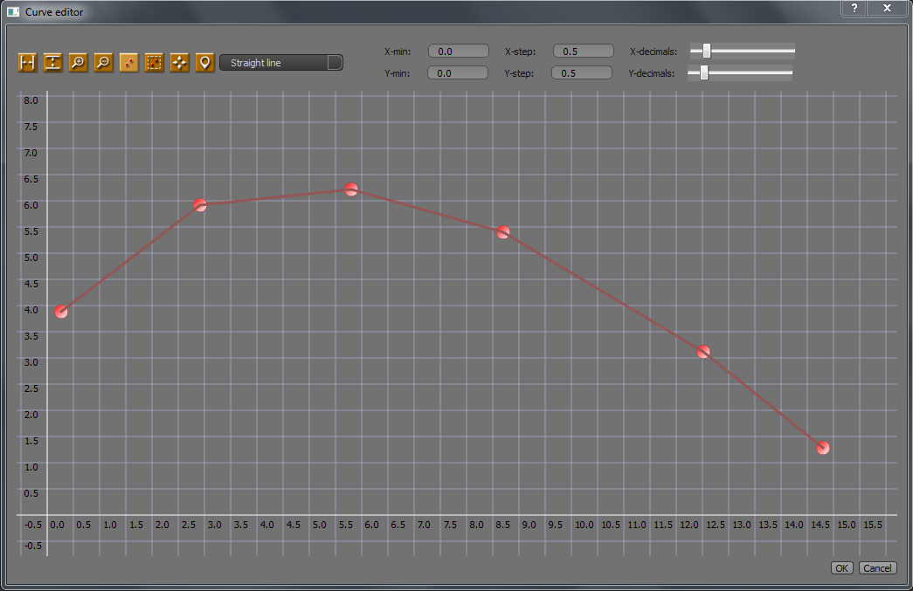

Files: asset_curve*.h / asset_curve*.cpp

Ogre asset library
Magus comes with a few Ogre asset widgets. These widgets are used for manipulating specific Ogre objects, such as cameras, entities, … By selecting the option ‘Use Ogre3d asset library’ in the Magus application, the associated files (including icons) are copied when a project is build. The project file is updated with the references.

If you want to use an Ogre asset widget, some additional code must be added.

An example:
Assume, the generated project contains a docking window, named ‘Properties’ with source properties_dockwidget.cpp. An Ogre camera asset widget can be added by means of the following piece of code:

#include "ogre_asset_camera.h"

//****************************************************************************/
PropertiesDockWidget::PropertiesDockWidget(QString title, MainWindow* parent, Qt::WindowFlags flags) :
QDockWidget (title, parent, flags),
mParent(parent)
{
mInnerMain = new QMainWindow();
setWidget(mInnerMain);

// Perform standard functions
createActions();
createMenus();
createToolBars();

// Ogre asset widget example
Magus::QtOgreAssetCamera* assetCamera = new Magus::QtOgreAssetCamera(QString("../common/icons/"));
Ogre::Camera* camera = parent->getOgreManager()->getOgreWidget(2)->mCamera; // Example
assetCamera->bindObject(camera);
mInnerMain->setCentralWidget(assetCamera);
}

An Ogre Camera (you decide which one, of course) is bound to the widget by means of:
void QtOgreAssetCamera::bindObject (Ogre::Camera* camera)

This is uni-directional. If a change is made in the Ogre asset widget, the Ogre camera is automatically updated. If the Ogre camera is changed in some other way, the Ogre asset widget is not updated.

The Ogre asset library can be added to a project by means of the Magus wizzard application. Create a new project and select ‘Use Ogre3d asset library’ on the General tab.

Ogre asset widget overview

QtOgreAssetCamera
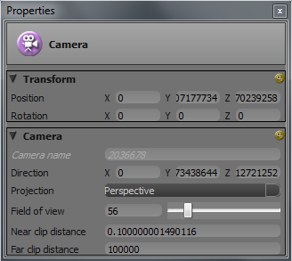

Files: ogre_asset_camera.h / ogre_asset_camera.cpp

QtOgreAssetEntity
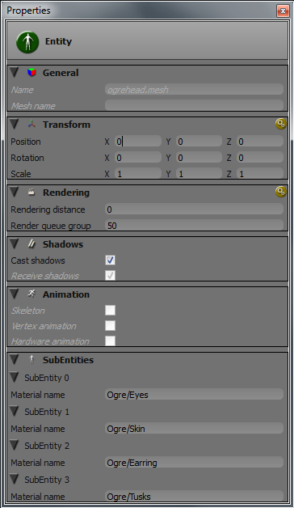

Files: ogre_asset_entity.h / ogre_asset_entity.cpp

QtOgreAssetMaterial
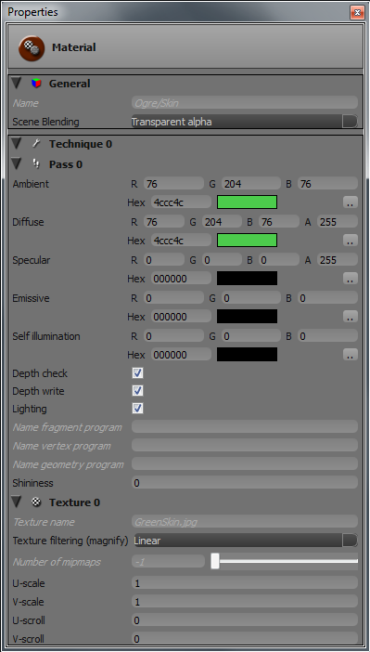

Files: ogre_asset_material.h / ogre_asset_material.cpp

QtOgreAssetLight
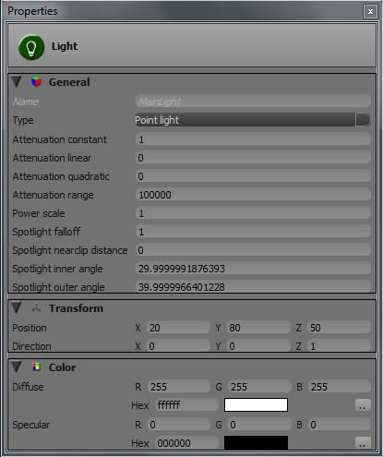

Files: ogre_asset_light.h / ogre_asset_ light.cpp

Node editor library
The node editor library comes with a node editor widget and some additional components. Selecting this option adds the relevant c++ files (and icons) to the project.

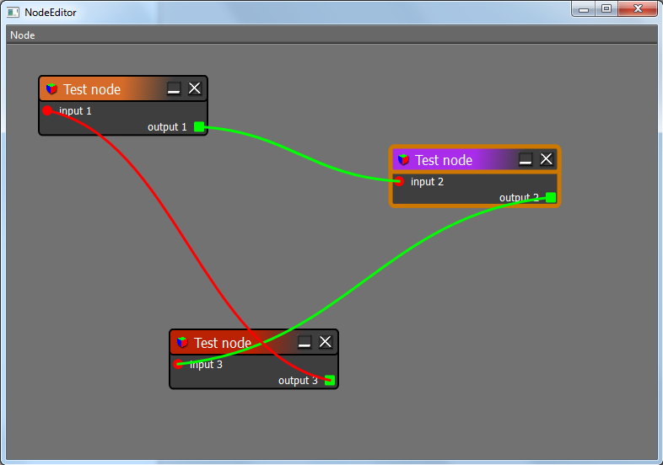

Files: node_*.h / node_*.cpp

The sample application ‘Node Editor’ shows how to use the node editor. Also the ‘Simple Material Editor’ application makes use of the Node editor library.

Tools library
The Tools library includes various widgets, such as a gradient editor and a texture selection widget. The sample application ‘Tools’ shows the widgets in action.

Gradient widget

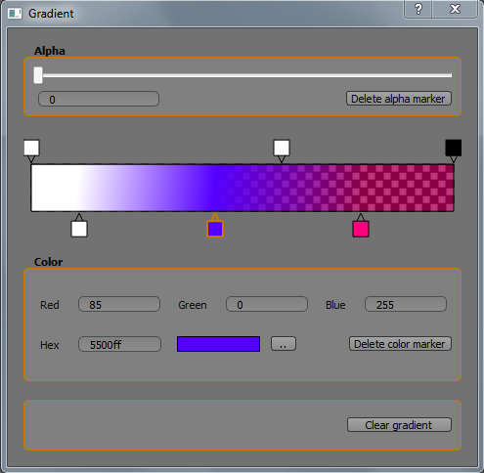

Files: tool_gradient*.h / tool_gradient*.cpp

Texture widget

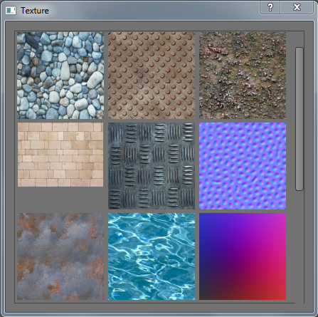

Files: tool_texturewidget.h / tool_texturewidget.cpp
tool_texturemodel.h / tool_texturemodel.h

Extended Texture widget

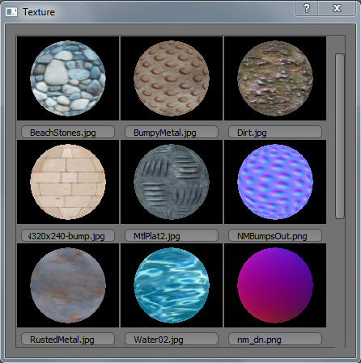

Files: tool_texturewidget_ext.h / tool_texturewidget_ext.cpp
tool_glspherewidget.h / tool_glspherewidget.cpp

Layer widget
The layerwidget is used to create a list of layers to which assets can be assigned. By means of a right mouseclick a context menu is enabled. The menu has a few items:
- Create empty layer
- Delete (selected) layer(s)
- Rename the selected layer
- Make all layers visible

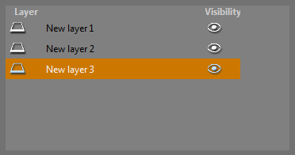

Files: tool_layerwidget.h / tool_layerwidget.cpp

Sceneview widget
The Sceneview widgets contains a list of assets, grouped by type.

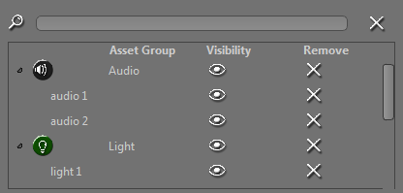

Files: tool_sceneviewwidget.h / tool_sceneviewwidget.cpp

Layered Sceneview widget
The Layered Sceneview widgets is a helper widget, consisting of a Layer widget and a Sceneview widget. Both widgets interact with each other. Groups and assets can be dropped onto a layer (dragged by means of another Sceneview widget) and show up in the Sceneview widget.

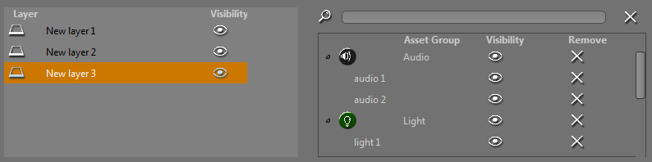

Files: tool_layered_sceneviewwidget.h /
tool_layered_sceneviewwidget.cpp
tool_sceneviewwidget.h / tool_sceneviewwidget.cpp
tool_layerwidget.h / tool_layerwidget.cpp

Sample applications

Node Editor
The Node Editor is a sample application that demonstrates the Node Editor widget (QtnodeEditor). It is located in the directory ‘samples/NodeEditor’.

Tools
This sample application shows the widgets of the Tools library in action. The Tools application is located in the directory ‘samples/Tools’.

Simple Material Editor
To see the node editor and the asset widgets in action, the Simple Material Editor is created, which works with version 1.9 of Ogre3d. The Simple Material Editor application is located in the directory ‘samples/SimpleMaterialEditor’.

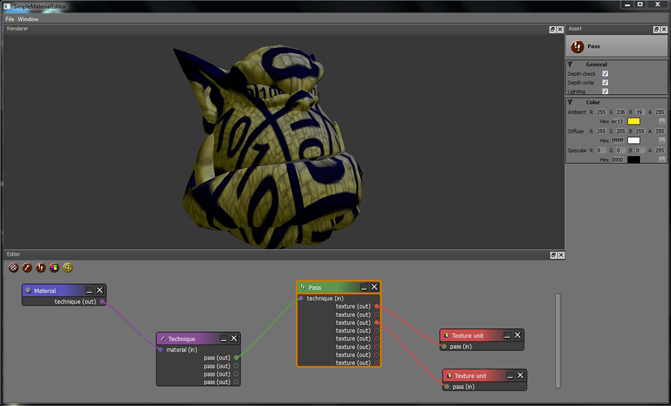

Let us analyse the application:

- The framework was generated by the Magus application. It contains the main.cpp and mainwindow.cpp / mainwindow.hpp and three docking windows:

asset_dockwidget.cpp/.h | Handles the asset widgets
editor_dockwidget.cpp/h | Contains the node editor code
renderer_dockwidget.cpp/.h | Contains the Ogre 3d rendering code

Some additional code was added, to get a working application.

- The asset library is included. These are all the files – except for asset_dockwidget.cpp/.h – with prefix ‘asset_’. These files are generated and used as is.

- The node editor library. These are all the files with prefix ‘node_’. These files are generated and used as is.

- The Ogre widget / rendermanager. These are all the files with prefix ‘ogre_’. These files are generated and used as is.

- The remaining files are the ones, which were not generated by the Magus application and are added by hand. These files all have the prefix ‘sme_’

EditorDockWidget – editor widget
In the constructor of the EditorDockWidget (in editor_dockwidget.cpp/h), the node editor widget (QtNodeEditor) is created:

// Create the node editor widget.
mNodeEditor = new Magus::QtNodeEditor(this);
connect(mNodeEditor, SIGNAL(nodeRemoved(QtNode*)), this, SLOT(nodeDeleted()));
connect(mNodeEditor, SIGNAL(nodeSelected(QtNode*)), this, SLOT(nodeSelected(QtNode*)));
mInnerMain->setCentralWidget(mNodeEditor);

The nodeSelected ‘slot’ of the EditorDockWidget is used to catch the nodeSelected ‘signals’ of the QtNodeEditor. Every time a node (QtNode) is selected, the corresponding asset is displayed in the AssetDockWidget (asset_dockwidget.cpp/h).

A small code excerpt from the nodeSelected ‘slot’ function:

void EditorDockWidget::nodeSelected(Magus::QtNode* node)
{
...
if (node->getTitle() == NODE_TITLE_MATERIAL)
{
Magus::QtAssetMaterial* assetMaterial = mParent->mAssetDockWidget->mAssetMaterial;
assetMaterial->setObject(static_cast<Magus::QtNodeMaterial*>(node));
mParent->mAssetDockWidget->setAssetMaterialVisible(true);
}
...

There are 4 derived QtNode classes for material, technique, pass and texture unit and are included in:
sme_node_material.cpp/.h,
sme_node_pass.cpp/.h,
sme_node_technique.cpp/.h and
sme_node_texture_unit.cpp).
These node classes are displayed on the QtNodeEditor ‘scene’ and contain their own attributes for material, technique, pass and texture unit. These attributes are used later to create the actual Ogre material (old materials; not the new 2.1 materials). The values of these attributes are manipulated by the asset widgets

In addition, the SME application also includes 4 asset classes that represent the material-, technique-, pass- and texture unit- properties (assets). These classes are included in files:
sme_asset_material.cpp/.h,
sme_asset_pass.cpp/.h,
sme_asset_technique.cpp/.h and
sme_asset_texture_unit.cpp/.h

The asset classes are displayed as widgets in the AssetDockWidget window.

EditorDockWidget – node creation
New nodes are placed on the editor widget by means of the toolbar buttons. The buttons activate the functions
EditorDockWidget::doMaterialHToolbarAction
EditorDockWidget::doTechniqueHToolbarAction
EditorDockWidget::doPassHToolbarAction
EditorDockWidget::doTextureHToolbarAction

EditorDockWidget – material generation
Function EditorDockWidget:doCogHToolbarAction creates the actual Ogre material. It uses the attributes of the nodes.

AssetDockWidget – asset creation
Asset widgets are created in the constructor of the AssetDockWidget.

Connection policies
If a port (QtPort) is created in a node (QtNode), there is an option to limit which other ports are allowed to connect. When a port is created, a port type (QtPortType) must be provided. This port type can be configured to define which connections are possible with other ports. An example:

// Define the connection policy
QtTechniqueOutPortType techniqueOutPortType;
QtMaterialInPortType materialInPortType;
techniqueOutPortType.addPortTypeToConnectionPolicy(materialInPortType);

In this example , techniqueOutputPortType only allows that connections with ports of type QtMaterialInPortType are allowed.

Magus – points of attention
- Sometimes, the build option from the Magus menu does not always create/copy all files. Try to build again if that happens. This is not a Magus bug.
- After a project is build again with Magus with some changed settings, compilation wit Qt Creator gives a link error. Delete the compilation dir (e.g. build-Layout2test-Desktop_Qt_5_3_MSVC2010_OpenGL_32bit-Debug) and compile again. This is not a Magus bug btw.
- Beware of namespace issues if you use signal/slots. If not properly used, the signals emitted from the Magus components are not received by the application; this is a known Qt ‘issue’.

